Assignment no: 03

Step 1: go to remix.ethereum.org

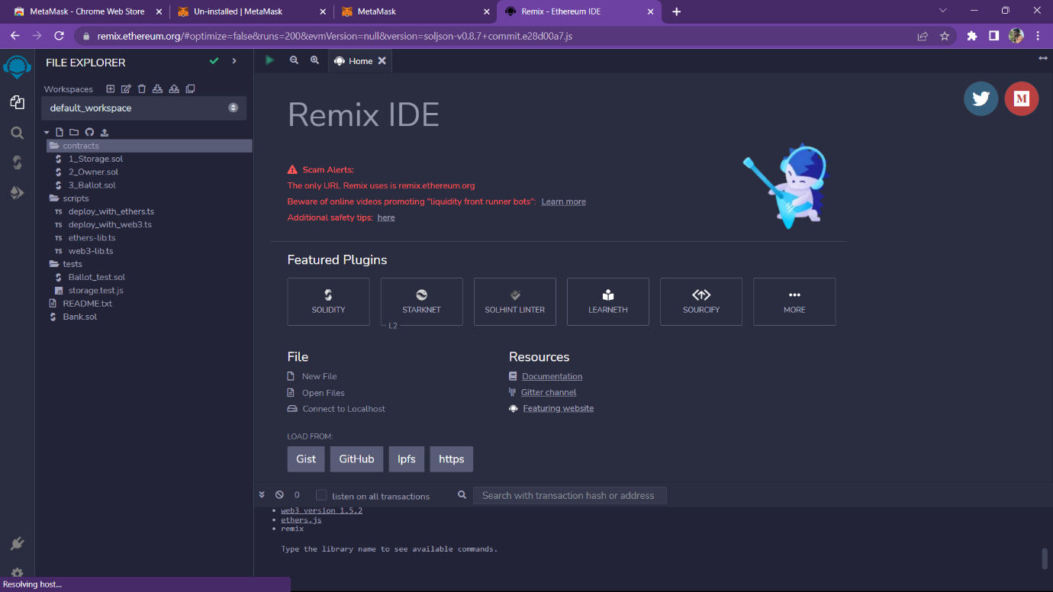

Step 2 click on new file and write a code.

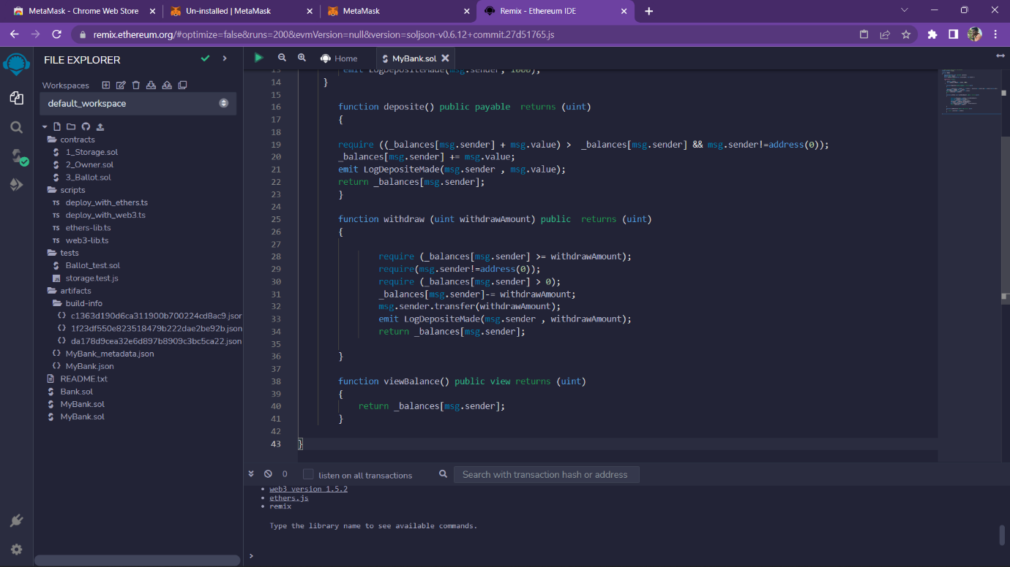

Source code:

//Tejas Chopda

// SPDX-License-Identifier: Unlicensed

pragma solidity ^0.6.0;

contract MyBank

{

mapping(address=> uint ) private _balances;

address public owner;

event LogDepositeMade(address accountHoder, uint amount );

constructor () public

{

owner=msg.sender;

emit LogDepositeMade(msg.sender, 1000);

}

function deposite() public payable returns (uint)

{

require ((_balances[msg.sender] + msg.value) > _balances[msg.sender] && msg.sender!=address(0));

_balances[msg.sender] += msg.value;

emit LogDepositeMade(msg.sender , msg.value);

return _balances[msg.sender];

}

function withdraw (uint withdrawAmount) public returns (uint)

{

require (_balances[msg.sender] >= withdrawAmount);

require(msg.sender!=address(0));

require (_balances[msg.sender] > 0);

_balances[msg.sender]-= withdrawAmount;

msg.sender.transfer(withdrawAmount);

emit LogDepositeMade(msg.sender , withdrawAmount);

return _balances[msg.sender];

}

function viewBalance() public view returns (uint)

{

return _balances[msg.sender];

}

}

Step 3: compile your code and run your code.

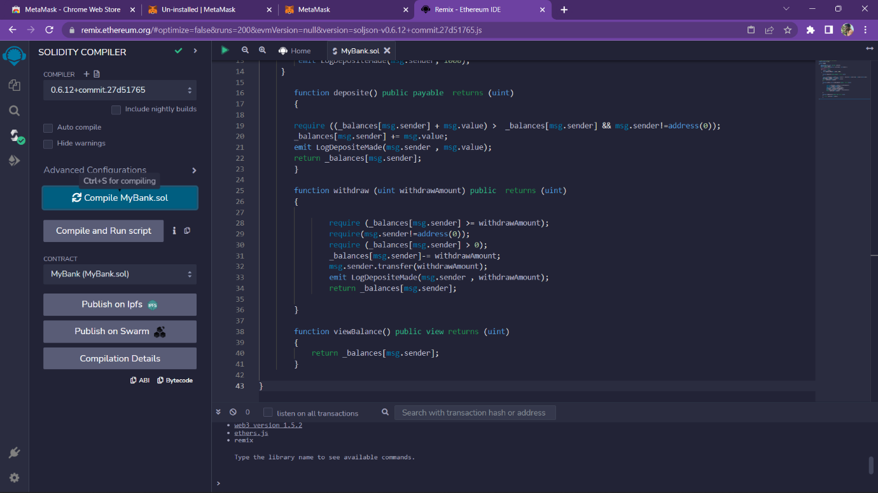

Step 4: Deploy your code.

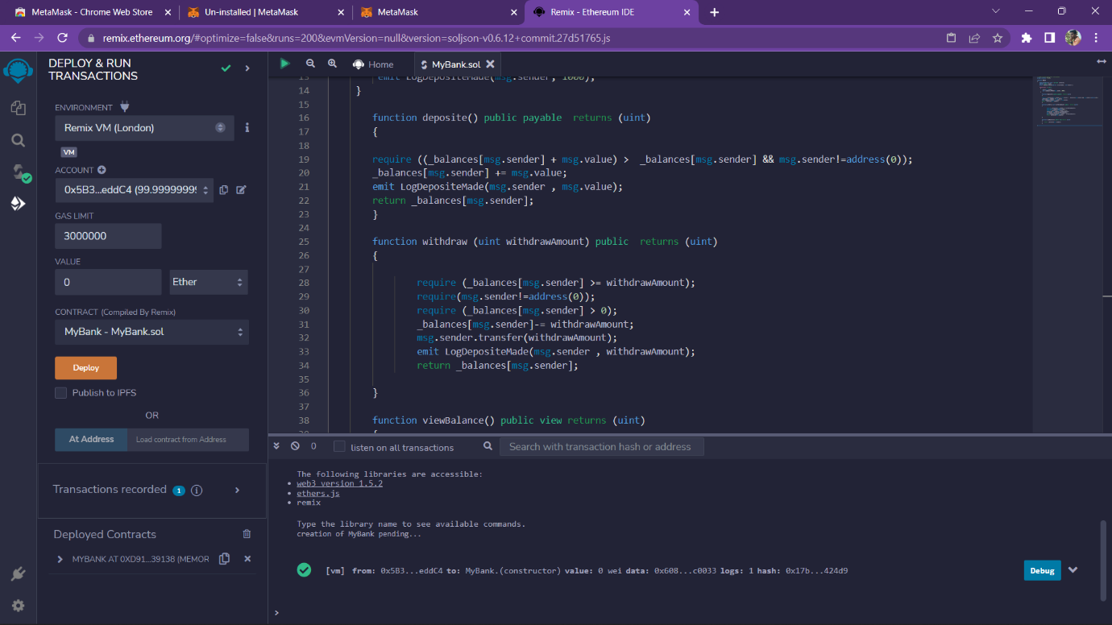

Step 5: Add and deposit Ethereum tokens.

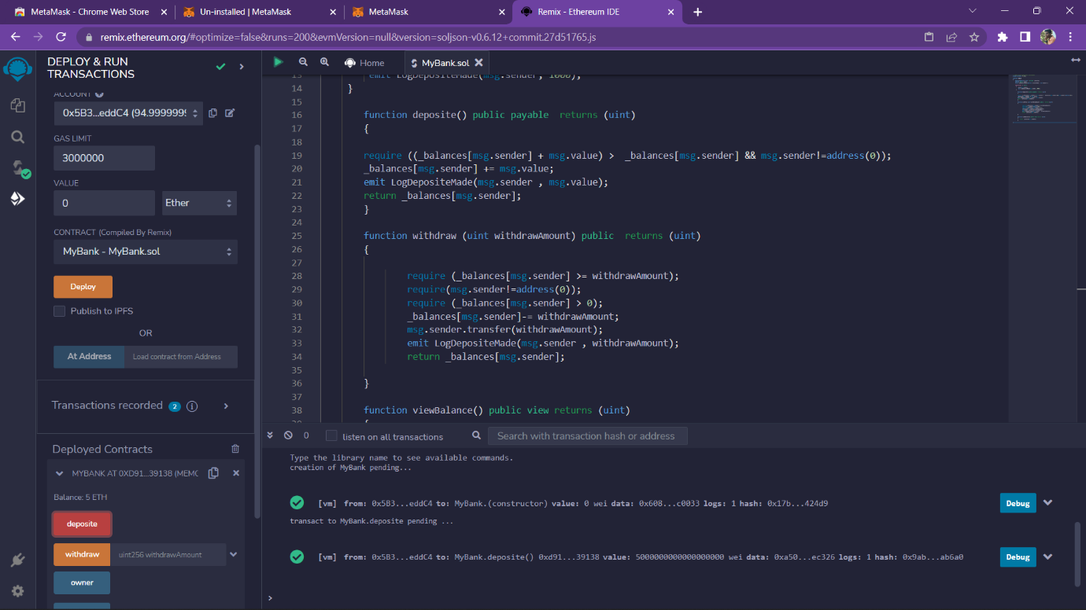

Step 6: click on owner tab to get owner’s address.

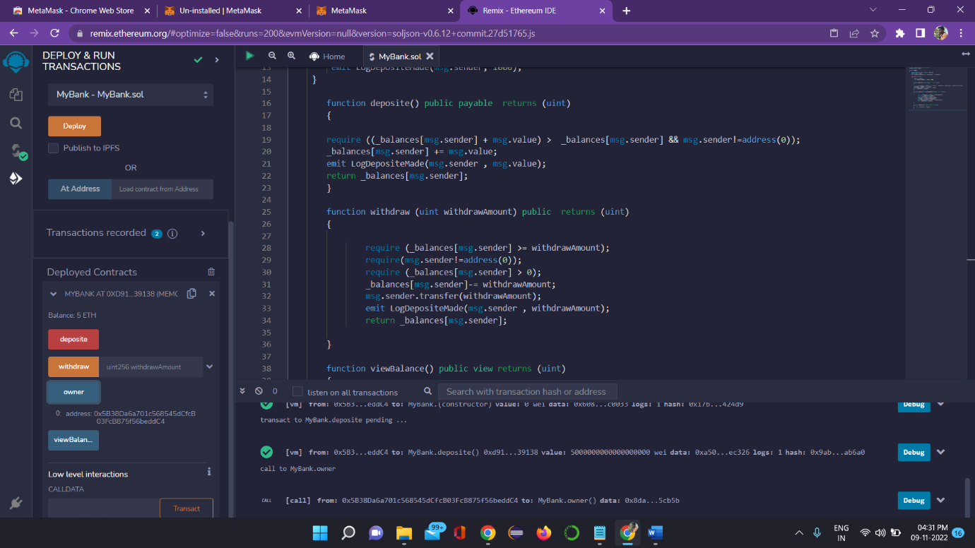

Step 7: click on viewBalance tab to get your token balance.

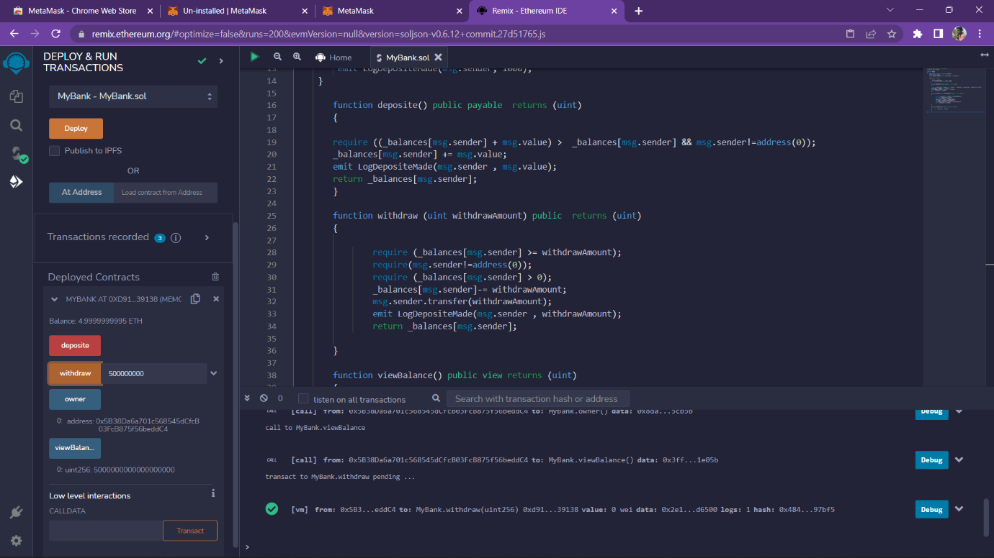

Step 8: click on withdraw tab to withdraw your tokens.

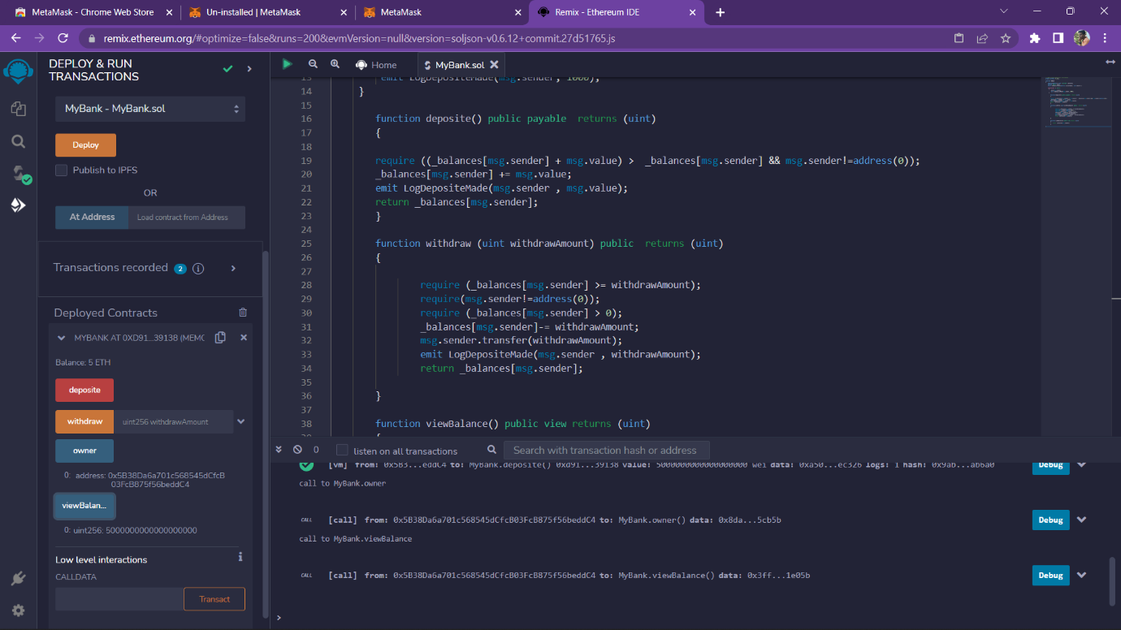

Step 9: Again check your balance.

